**DIGITAL MARKETING ASSIGNMENT**

**QUESTIONS**

1.Create a blog or website using Blogspot and WordPress. Customize the theme design and post new article with 500 words.

SCREENSHOT:

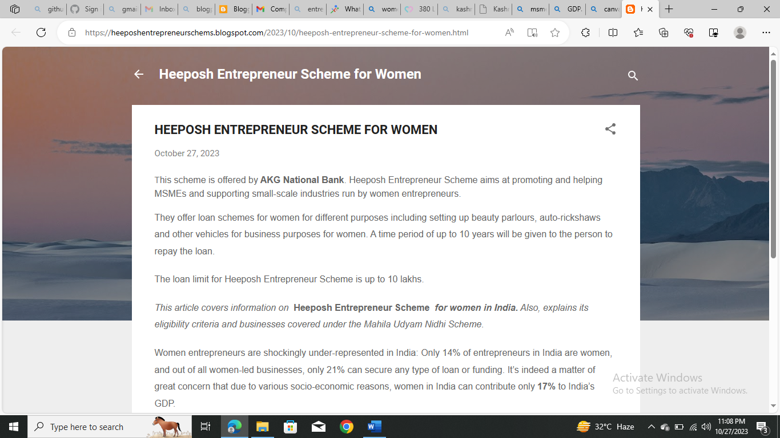

LINK:

[HEEPOSH ENTREPRENEUR SCHEME FOR WOMEN (heeposhentrepreneurschems.blogspot.com)](https://heeposhentrepreneurschems.blogspot.com/2023/10/heeposh-entrepreneur-scheme-for-women.html)

2. Create a New Facebook Business Page and post one social media poster for your brand.

SCREENSHOT:

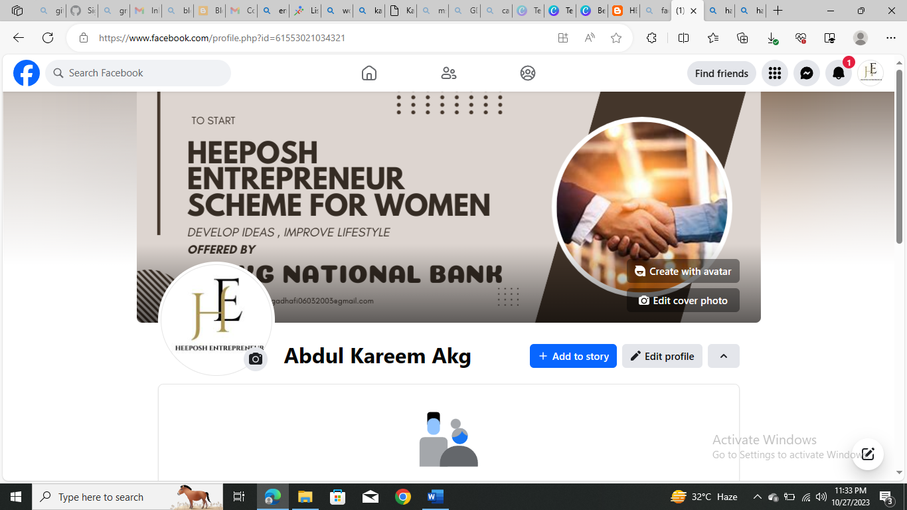

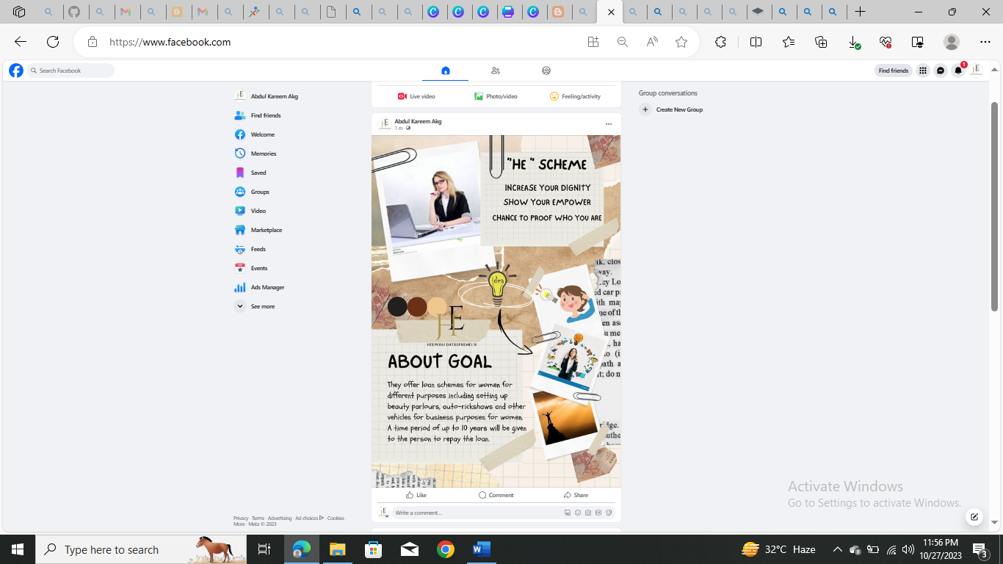

PROFILE LINK:

[(1) Facebook](https://www.facebook.com/profile.php?id=61553021034321)

POSTER LINK:

[(1) Facebook](https://www.facebook.com/photo/?fbid=122094714548100701&set=a.122094714566100701)

3. Create and design a social media advertisement poster using canva.

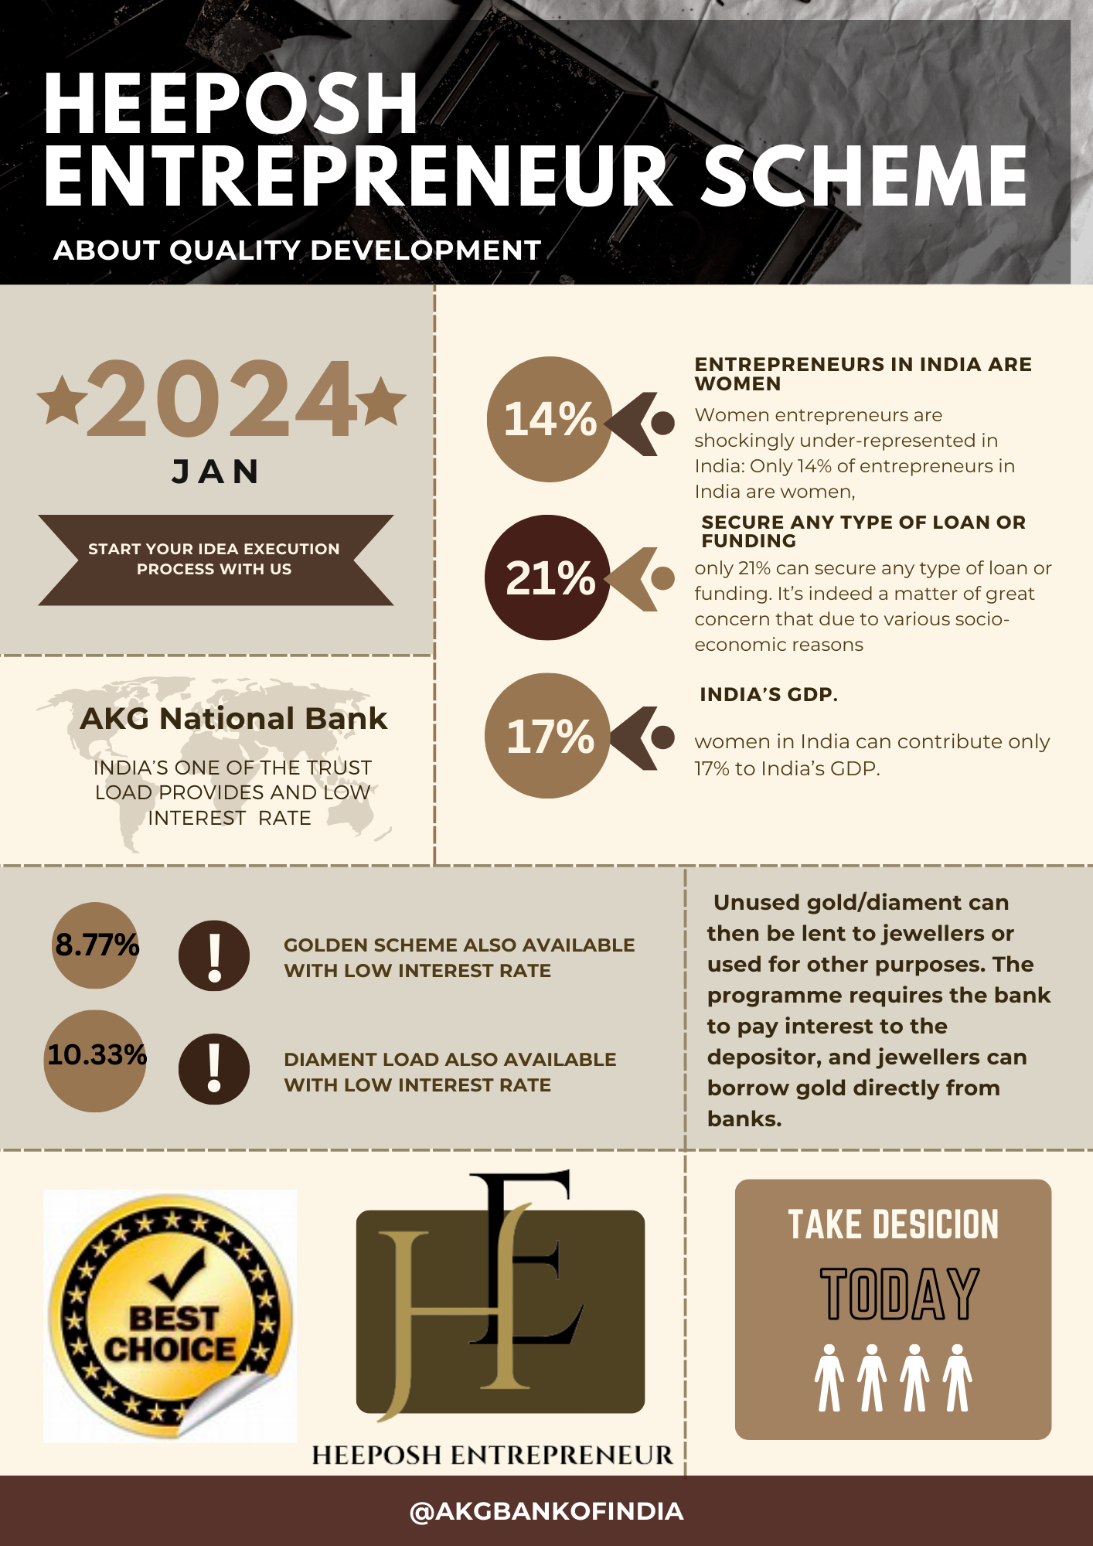

LINK:

https://www.canva.com/design/DAFyhyYHSPQ/NUuM4WOIK_yHPdA8uGxSgw/view?utm_content=DAFyhyYHSPQ&utm_campaign=designshare&utm_medium=link&utm_source=editor

4. Create email newsletter design using MailChimp or canva tool.

SCREENSHOT:

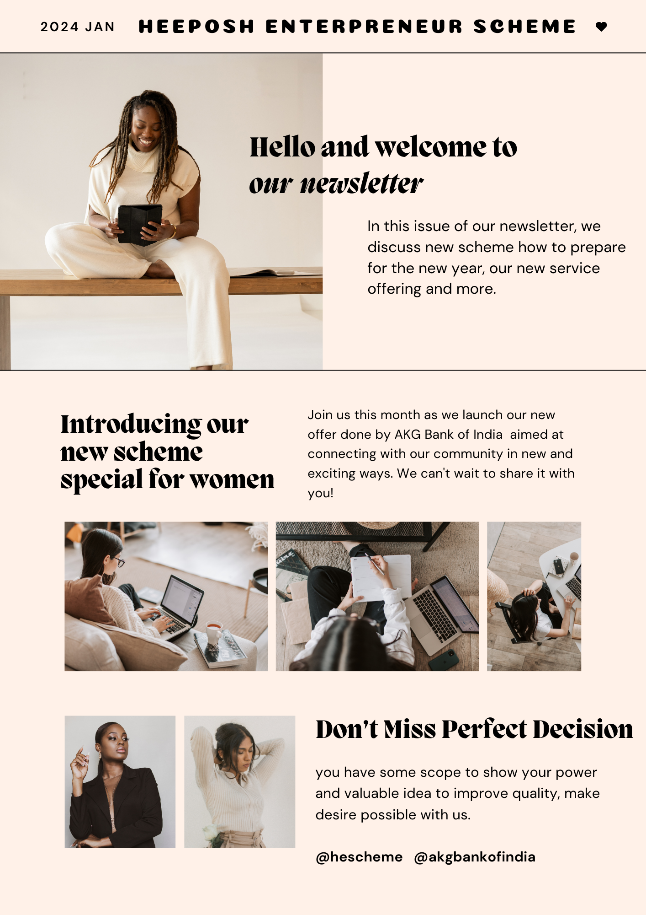

LINK:

https://www.canva.com/design/DAFyhzeBsLw/Ov8i7QMDnQnz0iGnnIZjFQ/view?utm_content=DAFyhzeBsLw&utm_campaign=designshare&utm_medium=link&utm_source=editor